Jan2019

Firm Name & Logo

| **Sun** | **mon** | **tue** | **wed** | **thu** | **fri** | **sat** |
| --- | --- | --- | --- | --- | --- | --- |
|  |  | 1 | 2 | 3 | 4 | 5 |
|  |  |  |  |  |  |  |
| 6 | 7 | 8 | 9 | 10 | 11  **Join us for your favorite drink and get energized for busy season!** | 12 |
|  |  |  |  |  | **Kickoff**  **Happy Hour** |  |
| 13 | 14 | 15 | 16 | 17 | 18 | 19 |
|  |  | **Omelet Breakfast** **Bar** |  | **Show your school spirit and come to the office decked out in your alma mater’s swag!** |  |  |
| 20 | 21 | 22 | 23 | 24 | 25 | 26 |
|  |  |  | **Fuel up with healthy snacks!** |  |  |  |
| 27 | 28  **Bring your favorite dish from home, we are hosting a potluck lunch!** | 29 | 30 | 31 |  |  |
|  |  |  | **Ten Key Race**  **We’re searching for the fastest fingers!** |  |  |  |

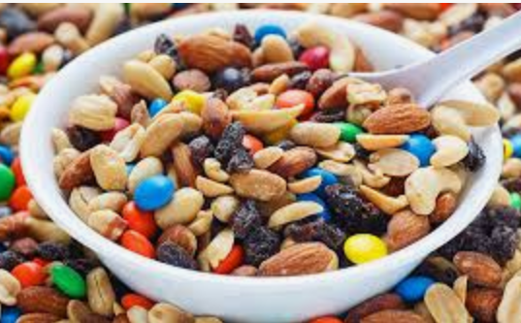Feb2019

Firm Name & Logo

| **Sun** | **mon** | **tue** | **wed** | **thu** | **fri** | **sat** |
| --- | --- | --- | --- | --- | --- | --- |
|  |  |  |  |  | 1 | 2 |
|  |  |  |  |  |  | **Breakfast on us!** |
| 3 | 4 | 5 | 6 | 7 | 8 | 9 |
|  | **It doesn’t matter who won – sport your favorite team’s apparel today!** |  |  |  | **Bring in a baby picture for a fun guessing game!** |  |
| 10 | 11 | 12 | 13 | 14 | 15 | 16  **A happy hour where we will highlight positive actions of our teammates.** |
|  |  |  | **Show your team spirit by wearing your favorite firm logo items!** |  | **Cheers**  **For**  **Peers** |  |
| 17 | 18 | 19 | 20 | 21 | 22 | 23 |
|  |  | **Thanks for all your hard work! Join us for lunch out of the office!** |  | **Task Takeover** |  |  |
| 24 | 25 | 26 | 27 | 28  **Give us your Target list and we’ll do the shopping for you!** |  |  |
|  |  |  | **Make Your Own Trail Mix** |  |  |  |

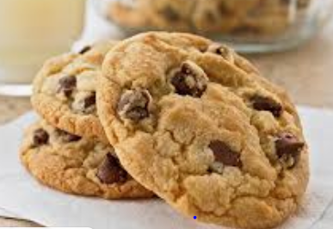Mar2019

Firm Name & Logo

| **Sun** | **mon** | **tue** | **wed** | **thu** | **fri** | **sat** |
| --- | --- | --- | --- | --- | --- | --- |
|  |  |  |  |  | 1 | 2 |
|  |  |  |  |  | **Employee Appreciation Day** |  |
| 3 | 4 | 5 | 6 | 7 | 8 | 9 |
|  | **Massage Monday** |  |  | **BBQ Lunch** |  | **Work from Home** |
| 10 | 11  **Back again by popular demand!** | 12 | 13 | 14 | 15 | 16 |
|  |  | **We’re celebrating all busy season birthdays! Join us for cake after lunch!** |  |  | **Wear as much green as possible to celebrate St Patrick’s Day!** |  |
| 17 | 18 | 19 | 20 | 21 | 22 | 23 |
|  |  | **Bring your laptop and your bracket for a working watch party!** |  |  |  |  |
| 24 | 25 | 26 | 27 | 28 | 29 | 30 |
|  | **Cookie Bake-Off**  **Break out that recipe book – #1 wins a prize!** |  |  | **Scavenger Hunt**  **All sorts of goodies are hidden around the office!** |  |  |

Apr2019

Firm Name & Logo

| **Sun** | **mon** | **tue** | **wed** | **thu** | **fri** | **sat** |
| --- | --- | --- | --- | --- | --- | --- |
| 31 | 1 | 2 | 3 | 4 | 5 | 6 |
|  |  | **Tuesday Tunes** | **Send us your favorite pump-up song to be added to a firm wide playlist!** |  | **Pizza Party Lunch** |  |
| 7 | 8 | 9 | 10 | 11 | 12 | 13 |
|  | **Minute To Win It Tournament** |  | **Ice Cream Sundaes** |  | **Beer &**  **Snack**  **Cart** | **We’ll be coming desk to desk with a Friday treat for you!** |
| 14 | 15 | 16 | 17 | 18 | 19 | 20 |
|  |  | **Office Closed!**  **You deserve it!** |  |  |  |  |
| 21 | 22 | 23 | 24 | 25 | 26 | 27 |
|  |  |  |  |  |  |  |
| 28 | 29 | 30 |  |  |  |  |
|  |  |  |  |  |  |  |